**DEPSTAR**

**CREATIVITY AND INNOVATION CLUB**

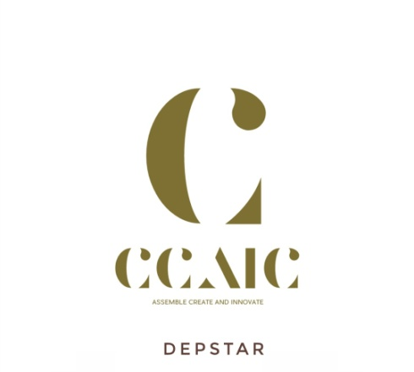

**Motto:**

Innovation we want more, Let creativity soar

Find how big you can dream, And we will make it happen.

**Vision and Mission:**

In the modern era where technologies are born from ideas, we strive to provide an open platform for all the students to share their creativity. Through creative tasks, we try to make them know about their hidden talents. We believe in potential of innovation which will lead us to a bright future. It aims in bringing talent and also inspire others to come up with their new ideas to the surface and help them towards building the ideas to products.

**Events:**

1. **Ideathon:**

Come up with new, innovative and creative idea to solve problems that affect humanity. Students were given the platform to propose their innovative ideas.

1. **ISearch:**

Online platform to share ideas.

1. **Blender Workshop:**

One day workshop for basic understanding of Blender software.

1. **Coming soon:**

Treasure hunt with coding.